**Question 1**

Suppose that Steve derives utility from the consumption of two goods, pizza and chips. Use the following table to answer the questions below.

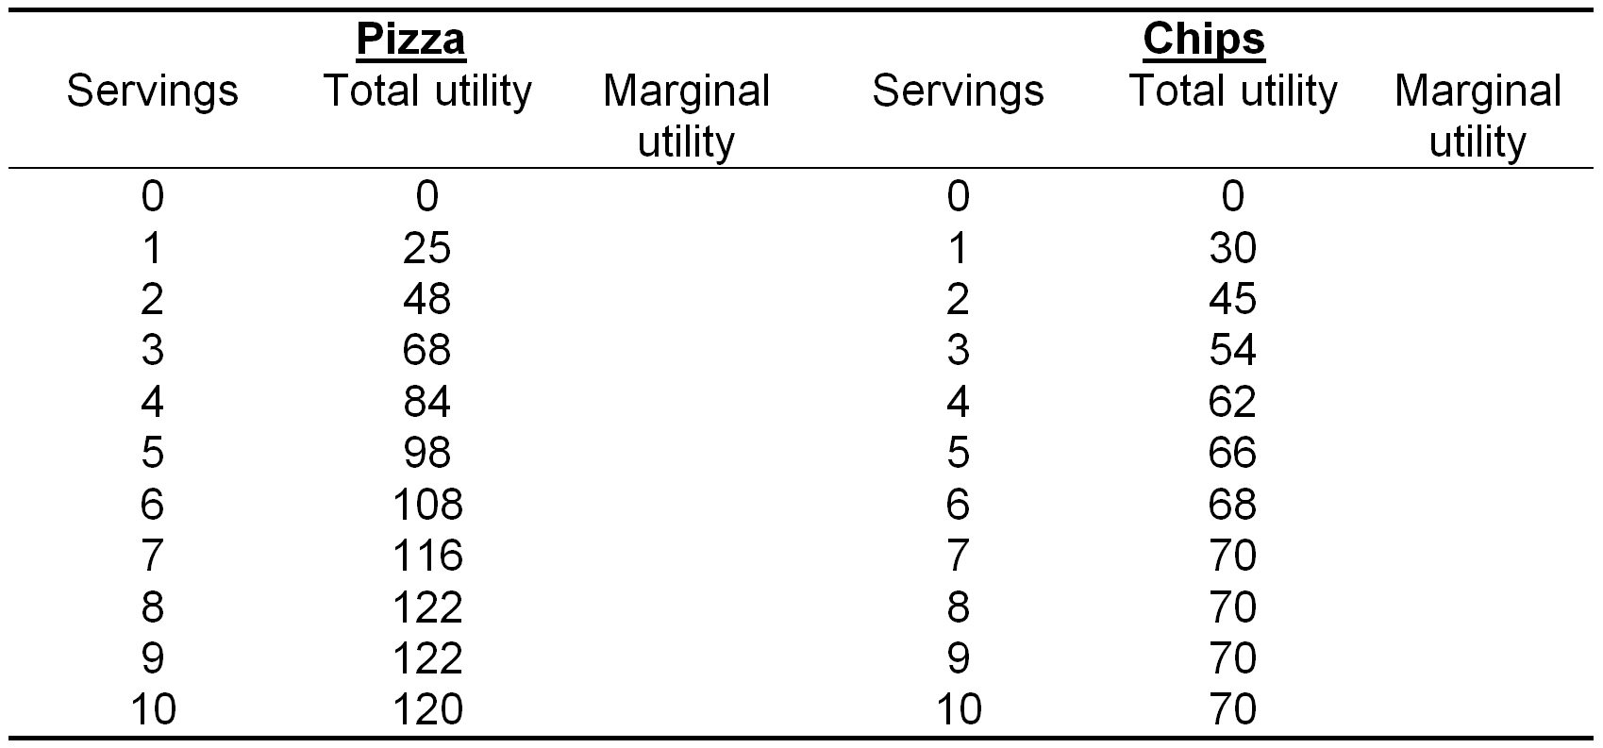

A. Complete the table.

B. If Steve has $40 to spend, pizzas are $10 each, and chips are $5 per serving, how many of each should Steve purchase to maximise his utility.

C. Suppose the price of pizzas rises to $20 each. What happens to Steve’s demand for pizzas and chips.

D. From the original example, suppose that Steve’s income increases to $60. What happens to his demand for pizzas and chips?

E. Are pizzas and chips complements or substitutes? Is each a normal or inferior good?

**Answer:**

A.

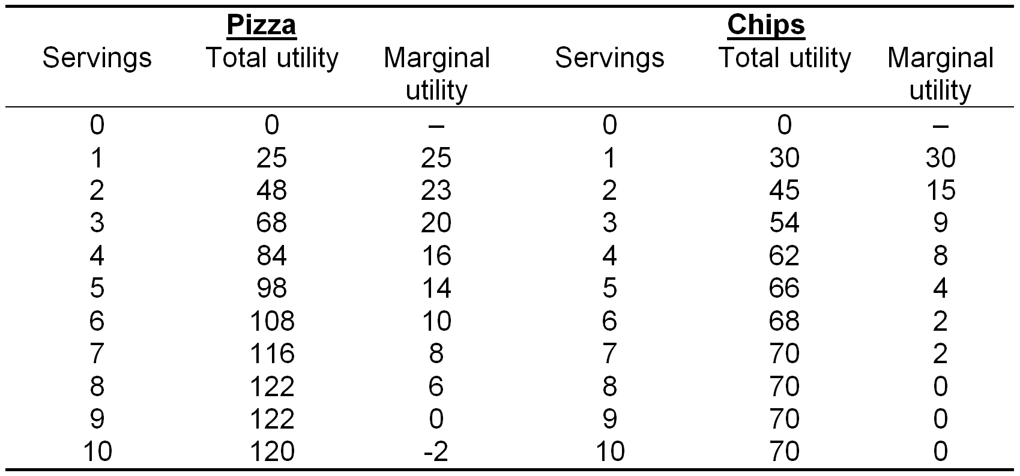

B.

Recall that Steve’s opportunity cost of purchasing one good is that the money he spends could have been used to purchase the other good. Thus, Steve should always buy the good that gives him the greatest marginal utility per dollar. The table below lists these amounts for both goods.

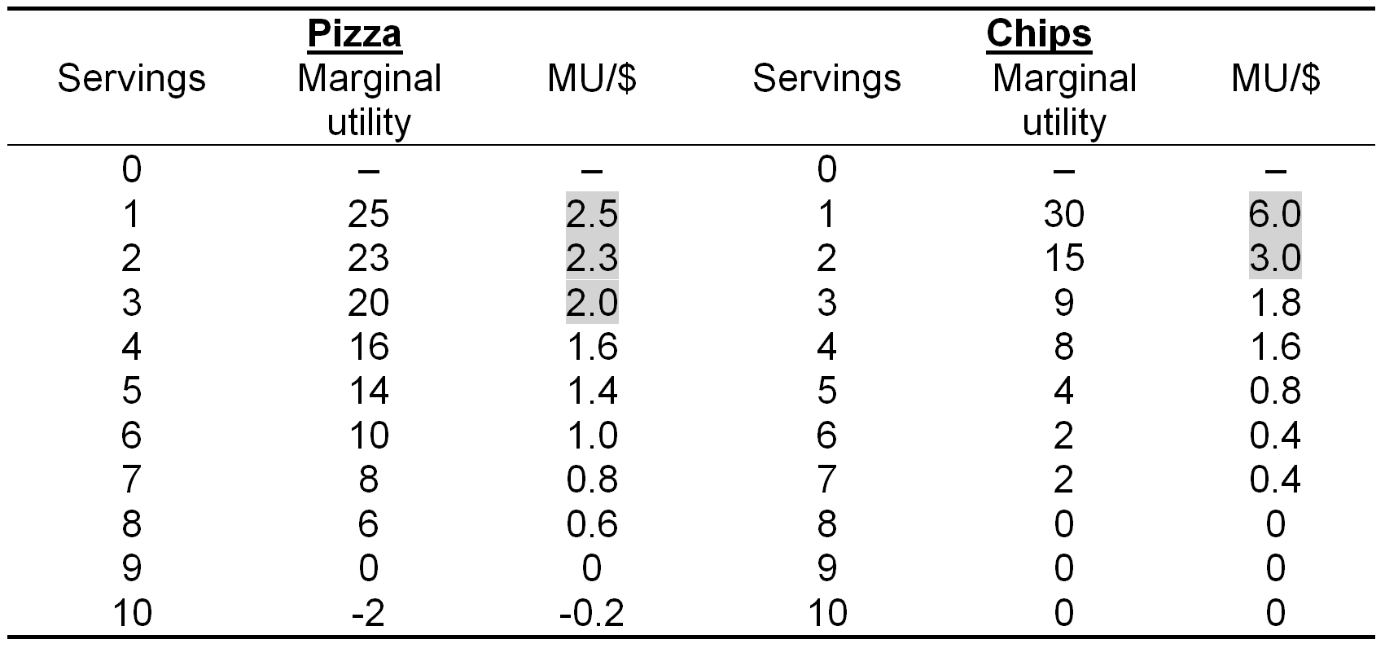

Using the table, the first good purchased should be a serving of chips, leaving Steve with $35. Next, he should purchase a second serving of chips, leaving him with $30, and then a pizza, leaving him with $20. Continuing in this manner, he should purchase two more pizzas, at which point he has spent his entire $40.

Therefore, Steve’s optimal bundle is 3 pizzas and 2 chips.

C.Pizzas decrease less,chips increase more pizza=1,chips=4

At the new prices, Steve’s utility is maximised at 1 pizza and 4 chips.

D.Pizzas increase,chips increase pizza=4,chips=4

With $60 to spend, Steve’s utility is maximised at 4 pizzas and 4 chips.

E.Substitute

Pizza normal

Chips normal

Pizzas and chips are substitutes because an increase in the price of pizzas caused an increase in demand for chips.

Both pizzas and chips are normal goods because an increase in Steve’s income caused him to consume more of both goods.

**Question 2**

Suppose that Stacy spends all her money on salads and kebabs. Further, suppose that salads are a normal good and kebabs are an inferior good.

A.Explain how an increase in the price of salads will affect Stacy’s demand for kebabs.

B. Explain how an increase in the price of salads will affect Stacy’s demand for salads.

C. Now suppose that kebabs are also a normal good. Explain how an increase in the price of salads will affect Stacy’s demand each kebabs.

**Answer:**

1. The increase in the price of salads will make kebabs relatively less expensive, so the substitution effect implies that Stacy will demand more kebabs. The increase in price all makes Stacey relatively poorer (in terms of her purchasing power). Because kebabs are an inferior good, the income effect also implies that Stacey will purchase more kebabs. Therefore, overall, Stacey will demand more kebabs.
2. The substitution effect implies that Stacy will buy fewer salads because they are relatively more expensive, and the income effect also implies that she will buy fewer salads because she is relatively poorer, and salads are a normal good. Therefore, overall, Stacey will demand fewer salads.

C. If kebabs were a normal good, then the substitution and income effects move in opposite directions, and we cannot say for sure what how Stacy’s demand for kebabs will change.

**Question 3**

Suppose that Harold spends money on candy bars and a bundle of other goods that costs $1. Harold has $15 to spend, and his utility from consuming these 9 goods is given by the following table:

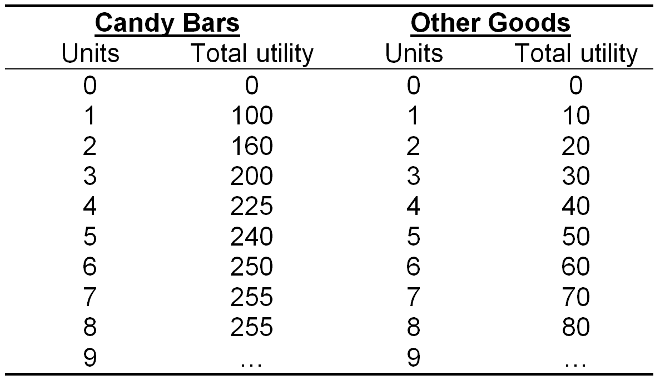

A. Calculate Harold’s marginal utility for each unit of both types of goods.

B. Calculate Harold’s reservation price for each candy bar he consumes.

C. Draw Harolds demand curve for candy bars.

**Answer:**

A.

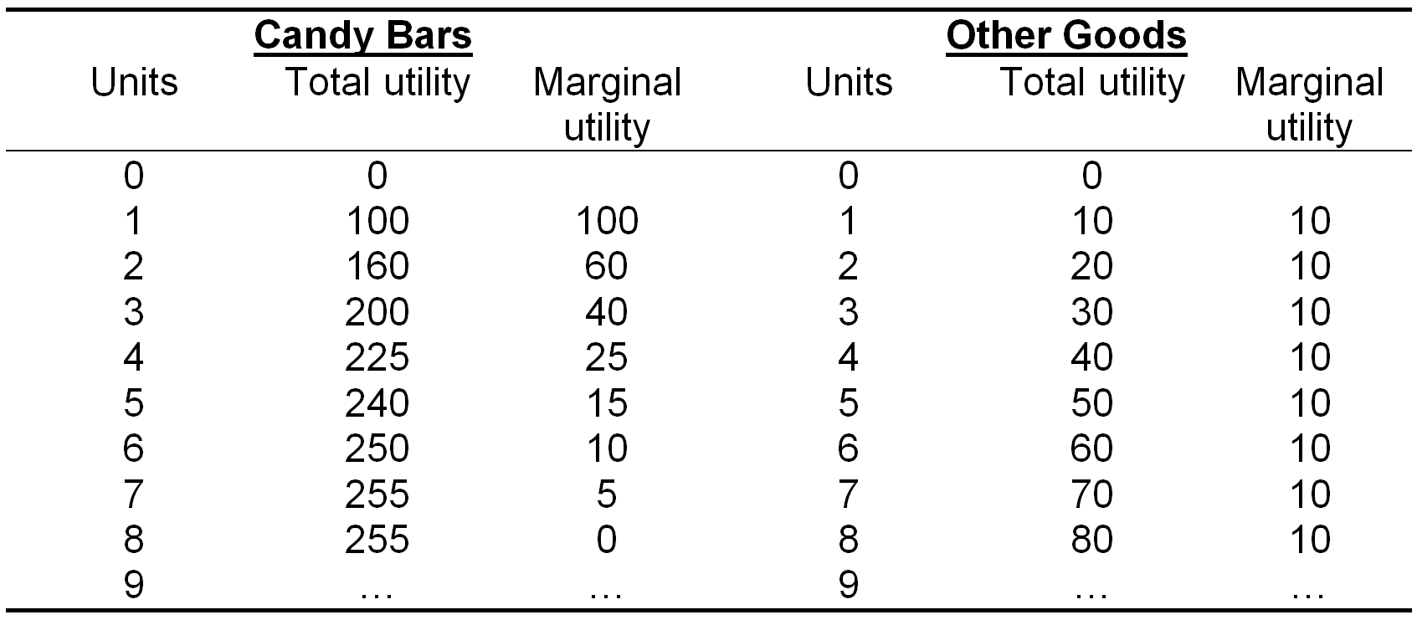

B.

Recall that Harold’s reservation price for a candy bar is the maximum amount he is willing to pay for that candy bar. Harold will be willing to buy an additional candy bar as long as the marginal utility he gains is greater than his opportunity cost, the amount of utility from other goods that he gives up.

Notice that, in this case, Harold’s marginal utility of consuming other goods is constant. Buying a bundle of other goods will always give Harold 10 utils per dollar spent. Then, to maximise his utility, Harold should buy a candy bar as long as it gives him at least 10 utils per dollar spent. Therefore, his reservation price for the first candy bar is $10 – the price for which he gets exactly 10 utils per dollar spent. His reservation price each additional candy bar is calculated in the same way.

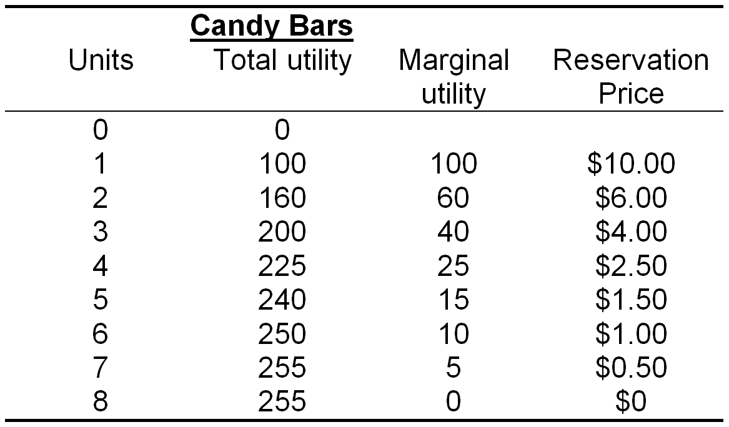

C.Recall the vertical interpretation of the demand curve. For each unit (on the horizontal axis), the demand curve is equal to the consumer’s reservation price for that unit. Therefore, Harold’s demand curve is a plot of his reservation prices.

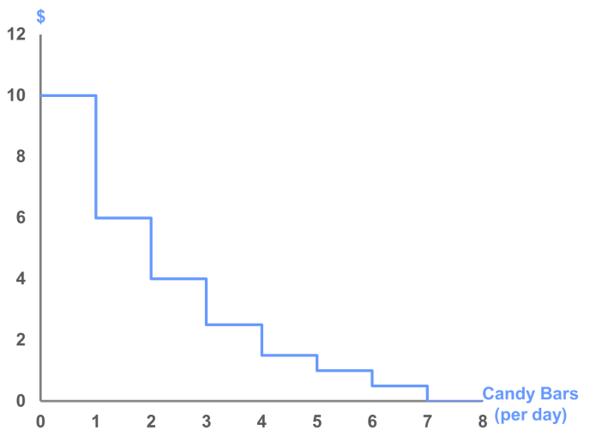

**Question 4**

Show on a graph and explain how each of the following scenarios is likely to affect the market demand for the product specified.

A. Apples: Due to a drought, the price of apples rises.

B. Coca Cola: A major supermarket chain reduces the price of Pepsi.

C. Automobiles: Petrol prices decrease and are widely expected to remain low for some time.

D. Airline tickets: The average income in Sydney increases by 10%.

E. Instant noodles: The government announces a policy that will result in a new $2,000 per year payment to university students to help cover living expenses.

**Answer:**

****A.****

An increase in the price of apples causes a movement *along* the demand curve. By the Law of Demand, an increase in the price of apples causes a decrease in the quantity demanded.

[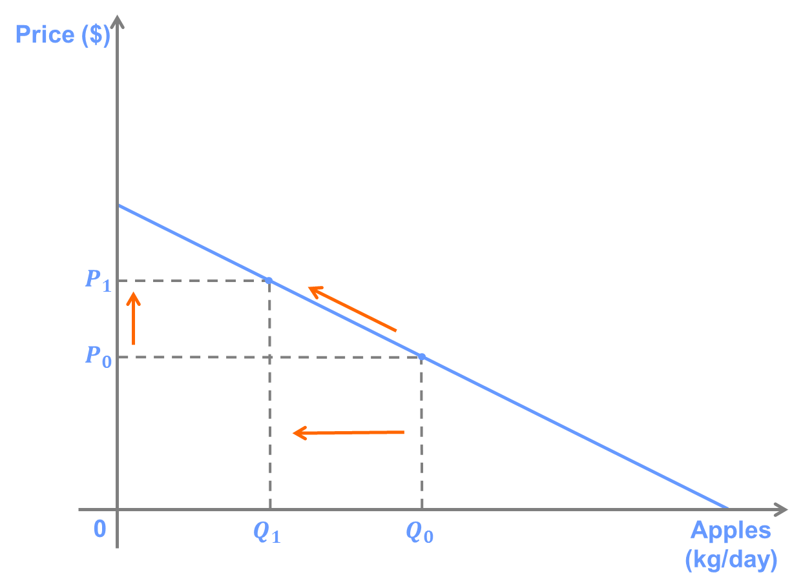](http://lionsheartstudios-publishing.com/unsw/wp-content/uploads/sites/17/2016/03/Ch3_Q4_Ans_A1.png)

****B.****

Because Coca Cola and Pepsi are substitutes, a decrease in the price of Pepsi will cause a decrease in demand for Coca Cola. On the graph, this is a shift to left of the demand curve for Coca Cola because the quantity demanded falls for any given price.

[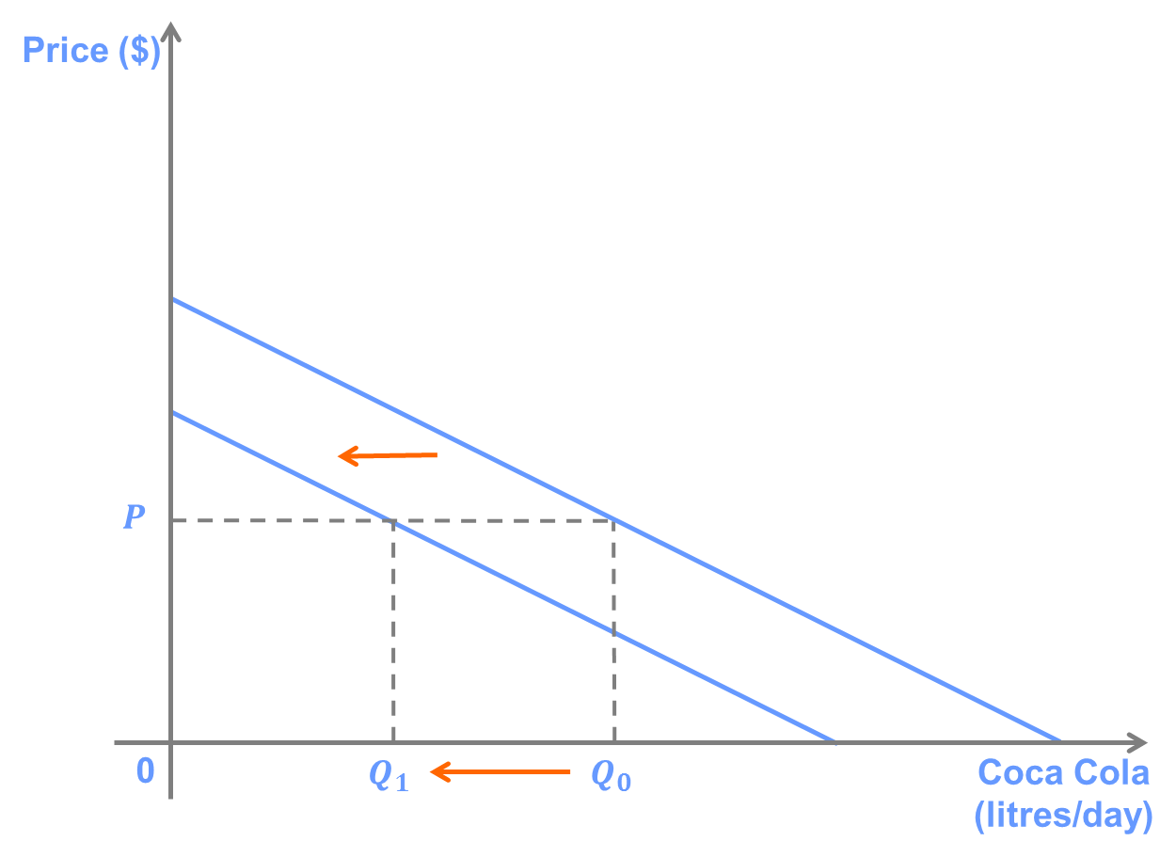](http://lionsheartstudios-publishing.com/unsw/wp-content/uploads/sites/17/2016/03/Ch3_Q4_Ans_B1.png)

****C.****

Because automobiles and petrol are complements, a decrease in the price of petrol will cause an increase in demand for automobiles. On the graph, this is a shift to right of the demand curve because the quantity demanded increases for any given price.

[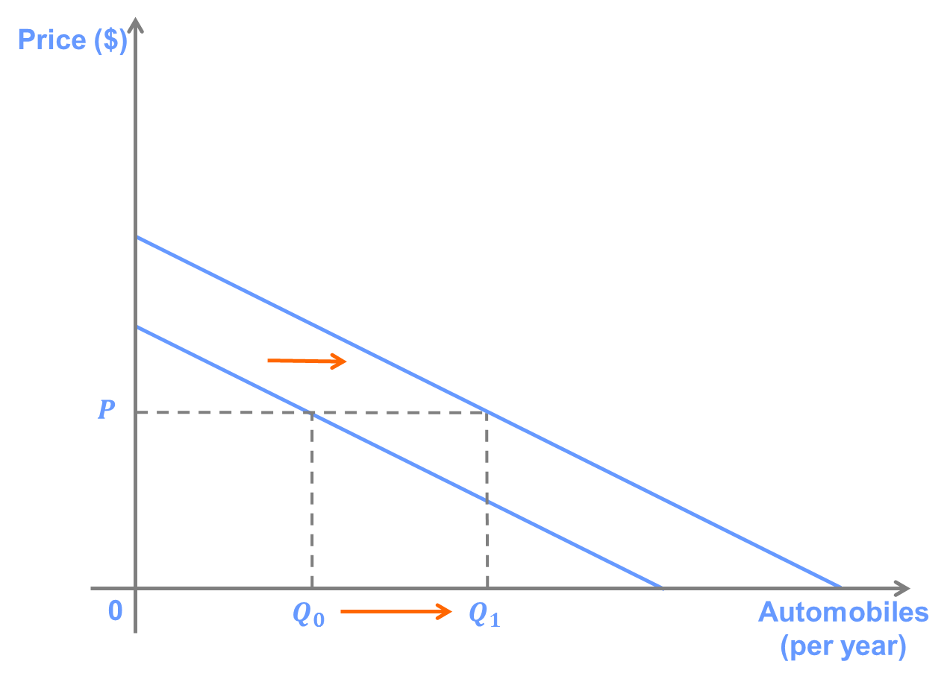](http://lionsheartstudios-publishing.com/unsw/wp-content/uploads/sites/17/2016/03/Ch3_Q4_Ans_C.png)

****D.****

Airline tickets are most likely a *normal* good, which means that demand increases when consumers’ incomes increase – that is, richer people tend to spend more money on travel. Thus, an increase in incomes in Sydney causes a shift to the right of the demand curve for airline tickets, which means that quantity demanded increases for any given price.

[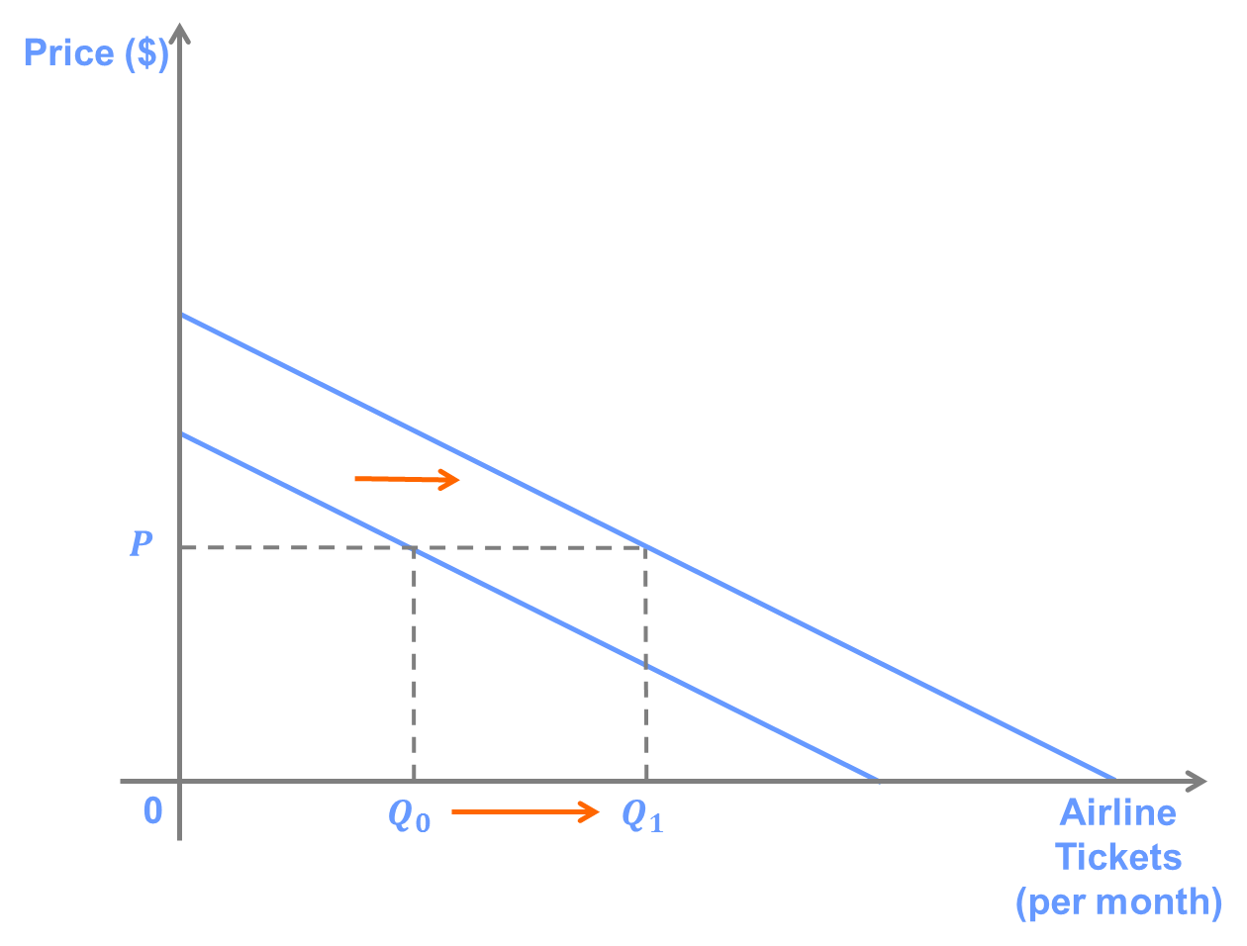](http://lionsheartstudios-publishing.com/unsw/wp-content/uploads/sites/17/2016/03/Ch3_Q4_Ans_D.png)

****E.****

Instant noodles are most likely an *inferior* good (university students tend to purchase more expensive types of food as their incomes rise). Because the new policy increases university students’ income, it causes a decrease in demand for instant noodles. This implies a shift to the left of the demand curve and a decrease in quantity demanded for any given price.

[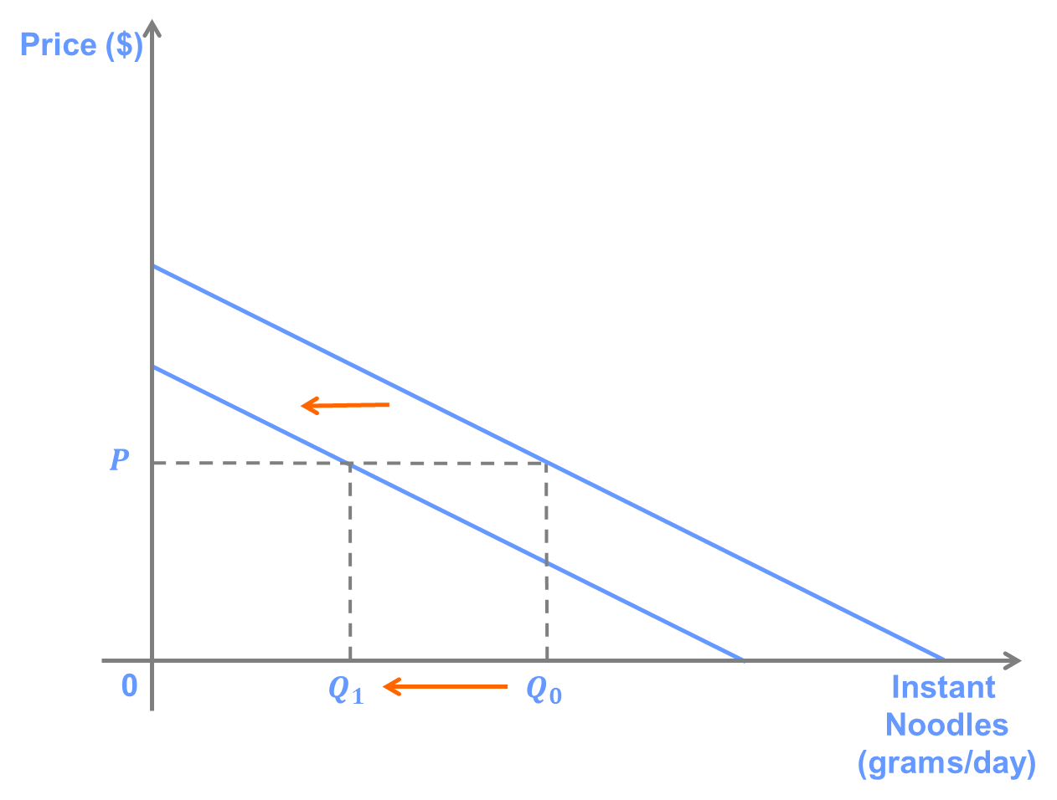](http://lionsheartstudios-publishing.com/unsw/wp-content/uploads/sites/17/2016/03/Ch3_Q4_Ans_E1.png)

**Question 5**

Consider the following demand curves:

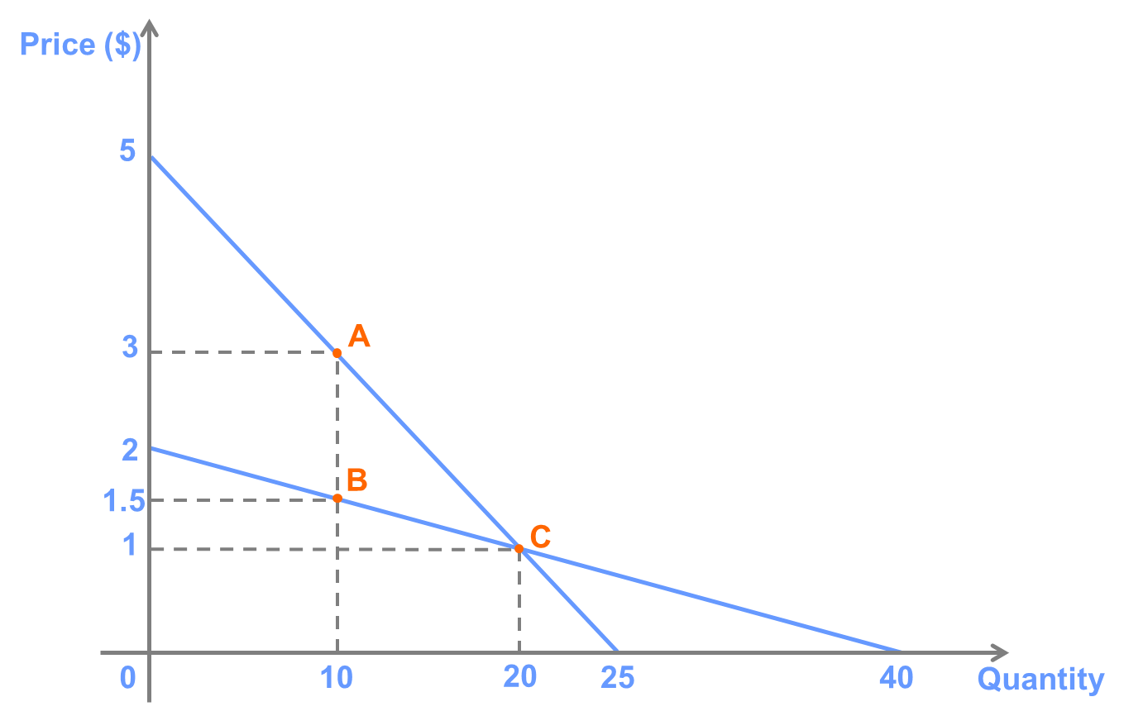

A. Calculate the price elasticity of demand at the points labelled in the above graph.

B. Which of the two demand curves is most likely to represent demand for a good with relatively close substitutes?

Answer:

1. EA=(1/-0.2)*(3/10)=-1.5

EB=(1/-0.05)*(1.5/10)=-3

EC=(1/-0.2)*(1/20)=-0.25 EC=(1/-0.05)*(1/20)=-1

The formula for elasticity is (P/Q)x(1/slope). The price elasticity of demand at each point is:

A: (3/10)x-5 = -1.5

B: (1.5/10)x-20 = -3

C: (1/20)x-5 = -0.25 (For the line containing point A)

(1/20)x-20 = -1 (For the line containing point B)

B.The curve BC

The demand curve that contains point B has a lower slope (in absolute value). This means that, for a given price and quantity, it will have a higher elasticity (in absolute value).

A higher elasticity means that the quantity demanded is more responsive to a change in the price. This is true for products with close substitutes, since it is easier for consumers to switch to a lower-priced alternative when the price of a product increases. Thus, the flatter line represents demand for a good with closer substitutes.

**Question 6**

The following graph shows two different demand curves.

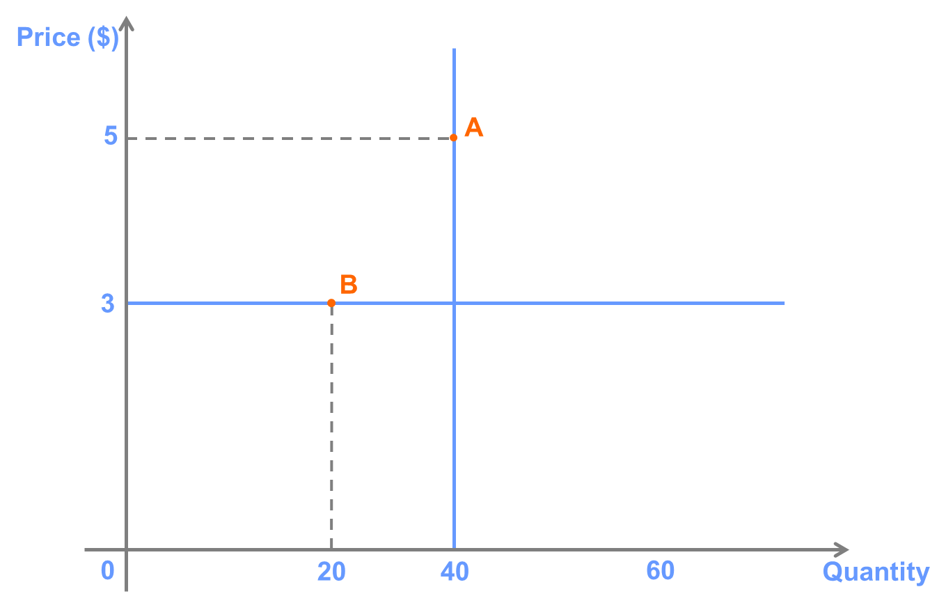

1. What is the price elasticity of demand at the two points labelled in the graph?

B. What types of goods might have demand curves that looks like those in the graph?

**Answer:**

1. EA=0,EB=∞

To answer this question, we have to recall from high school algebra that the slope of a horizontal line is equal to zero, and the slope of vertical line is infinite. Thus, the price elasticity at point A is (5/40)x(1/∞) = 0, and the elasticity at point B is (3/20)x(1/0) = ∞. In fact, we can see that it does not matter at what point on the demand curve we calculate the elasticity. It will always be zero on the vertical demand curve and infinite on the horizontal demand curve.

Economists refer to a horizontal demand curve as perfectly elastic. If demand is perfectly elastic, consumers will buy as much of the good as is available if the price is below a certain point (in this case $3) and zero if the price is above that point. Economists refer to a vertical demand curve as perfectly inelastic. If demand is perfectly inelastic, consumers will buy a fixed amount of the good no matter what the price is.

1. A--coffin B--The bank purchases gold at a given price

There are very few (if any) goods that that have perfectly elastic or perfectly inelastic demand (they are extreme examples), but there are many that are close.

Goods with very close substitutes will have close to perfectly elastic demand. For example, suppose that there are white taxis and gray taxis. As long as a white taxi is available, demand for gray taxis will be close to perfectly elastic. Consumers will demand gray taxis as long as the price is below that charged by white taxis, but very few people will take a gray taxi if the price is greater than the white taxi.

A life-saving drug is an example of a good with close to perfectly inelastic demand. If having a certain dose of the drug means the difference between living and dying, most consumers will pay any price for the drug, but they would not consume any more if the price were to fall.

**Question 7**

Suppose that demand for tickets to a movie theatre is given by P = 50 - 0.5Q.

A. Calculate the elasticity of demand at P = $30 and P = $20.

B. Suppose that the theatre owner is thinking of lowering the price of movie tickets. How would the theatre’s revenue change if it lowered the price from $30 to $29? What about from $20 to $19?

C. Can you think of a reason why the effect of a change in price on revenue might be different in the two cases?

**Answer:**

A.P=$20,E=(1/-0.5)*(20/60)=-0.67

P=$30,E=(1/-0.5)*(30/40)=-1.5

The slope of the demand curve is -0.5. The elasticity at P = 30 is (30/40)x(1/-0.5) = -1.5. The elasticity at P = 20 is (20/60)x(1/-0.5) = -0.67.

B.TR=P*Q=30*40=1200

TR=P*Q=29*42=1218 increase

TR=P*Q=20*60=1200

TR=P*Q=19*62=1178 decrease

Revenue is equal to (Price x Quantity).

Lowering the price from $30 to $29 changes revenue from $30×40 = $1,200 to $29×42 = $1,218, an increase of $18.

Lowering the price from $20 to $19 changes revenue from $20*60 = $1,200 to $19*62 = $1,178, a decrease of $22.

C. In the first case, demand is elastic, while in the second case demand is inelastic. When demand is elastic (elasticity greater than 1, in absolute value), it means that the percentage response of quantity demanded is greater than the percentage change in price. Since revenue depends on both price and quantity, lowering the price when demand is elastic increases revenue, because the increase in quantity is greater than the decrease in price. When demand is inelastic, the opposite is true.